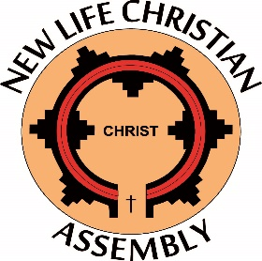
Volunteer Registration
Information
First Name:____________________________ Last Name: ______________________________
Age/DOB:_________________ Gender: Female □ Male □
Address: ______________________________________________________________________
City: _________________________________ST: __________ Zip Code: __________________
Email: _________________________________________ Phone (_____) ________-_________
Parent Name (if under 18): _________________________________________________
Parent Phone (if under 18): _________________________________________________
Emergency Contact during event: __________________________________________________
Emergency Contact Phone: _______________________________________________________
Background checks are required for ALL volunteers over the age of 18.
- I have and can provide a background check within the last 12-18 months: YES □ NO □
Former Special Needs Skills/Training (Please check all that apply):

□ Fluent in American Sign Language (ASL)
□ Special Education Teacher
□ Healthcare Professional (if so, please list field ___________________________)
□ Current Volunteer in ___________________________________ Special Needs Ministry
^{(Church’s Name)}
□ Other

If other, please explain: __________________________________________________________

I have Volunteered at Night to Shine before: YES □ NO □
Volunteer Role Requested (we will consider your request but cannot guarantee a specific role):
______________________________________________________________________________
Additional Notes or Concerns: _____________________________________________________
______________________________________________________________________________
______________________________________________________________________________
Remit form to:
New Life Christian Assembly
P.O Box 547
Church Rock, NM 87311
Night-to-shine@newlifechristianassembly.org

